**OWSCA Tutorial**



**This tutorial aims to show all the steps for the execution and treatment of the OWSCA methodology in molecular dynamics calculations.**

*For more information on the owsca methodology see the articles:* [**https://doi.org/10.1007/s00214-016-2037-z**](https://doi.org/10.1007/s00214-016-2037-z)

[**https://doi.org/10.1007/s00214-021-02816-y**](https://doi.org/10.1007/s00214-021-02816-y)

[**https://doi.org/10.1002/qua.25896**](https://doi.org/10.1002/qua.25896)

**Steps**

**Code Execution:**

1. The OWSCA routine is executed in the MatLab program. Thus, for its execution, the matlab package must be installed on the user's computer.
2. The routine files are inside a folder called OWSCA, it is very important that all the files (objfun, OWSCA, SIG and T) are inside the same folder.
3. The SIG file is the energy obtained from the molecular dynamics calculations (DM). Therefore, this file needs to be changed for the energies that are under study.
4. The T file is the times obtained from the MD calculations, it is also necessary that this file be changed. The SIG and T files must have the same energy and time number, otherwise the routine execution will fail.
5. In the file named ‘OWSCA’ the variable ‘wname’ is the type of wavelet used. For each type of system a specific wavelet is needed. Below we show some wavelets used for some systems.

**Transition metals (ex: Fe2+, Mn2+ e etc):** Wavelet bior 1.3

For more information:

<https://doi.org/10.1007/s00214-021-02816-y>

**Organic compounds:**

Flexible organic compost: Wavelet rbio3.1

Non-flexible organic compost: Wavelet db1

Proteins: Wavelet rbio1.1

Other works are being developed to validate the routine for other systems.

1. After these steps, we have to run the OWSCA routine in MatLab. Figure 1 shows the MatLab interface with the OWSCA routine, the red circle os where you should run the routine.

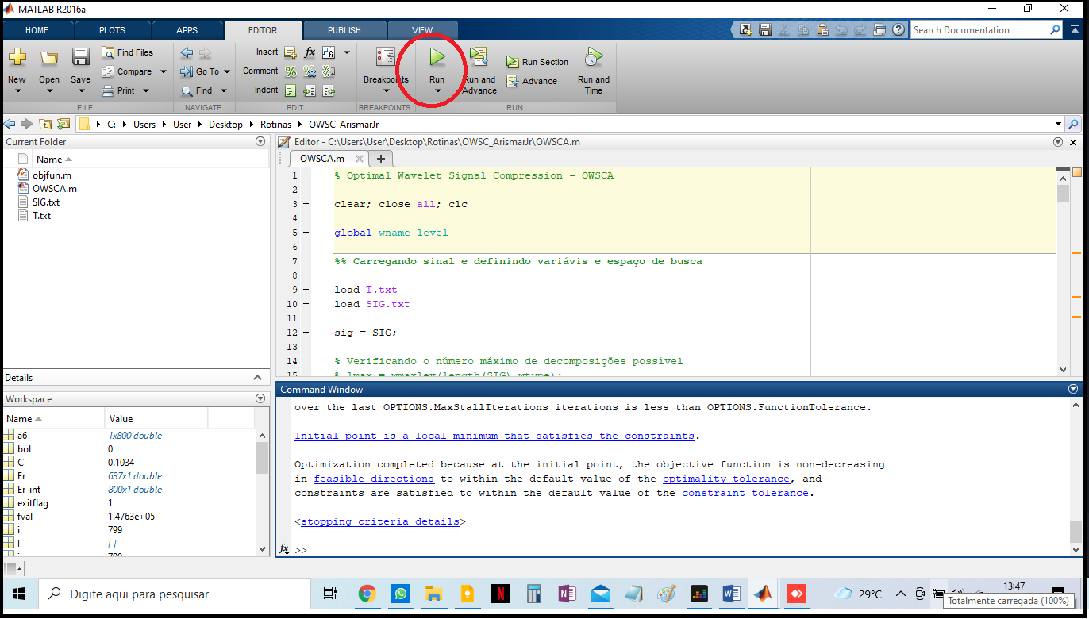

Figure 1. MatLab interface with the OWSCA routine

**Treatment of results:**

1. After running the routine, two figures will appear. Figure 2 refers to the number of levels (thresholds) used in the signal decomposition and figure 3 refers to the original signal (blue) and the decomposed signal (red).

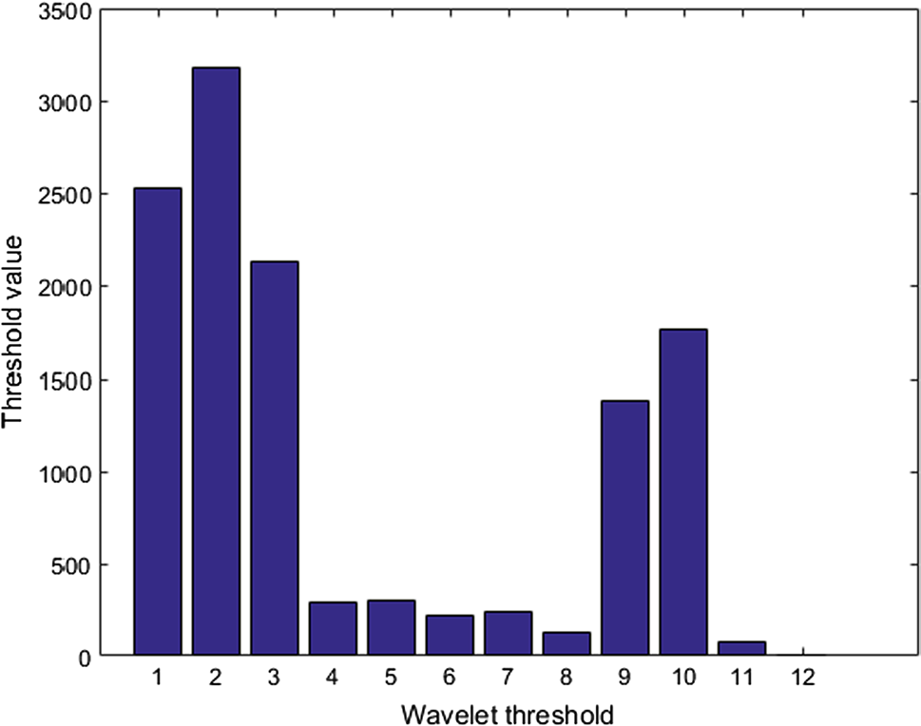

Figure 2. Optimal thresholds δj* (vertical axis: threshold value; horizontal axis: individual threshold)

C:\Users\User\Desktop\bior1.5.tif

Figure 3. Energy of MD (original and compressed) at each time

**2 .** The selection of the structures' conformations is given by **Figure 3**. Thus, each step in red corresponds to a conformation. The total number of conformations will be the sum of the number of steps obtained by the red sign in **Figure 3**.